Bulkington
Annual Parish Meeting

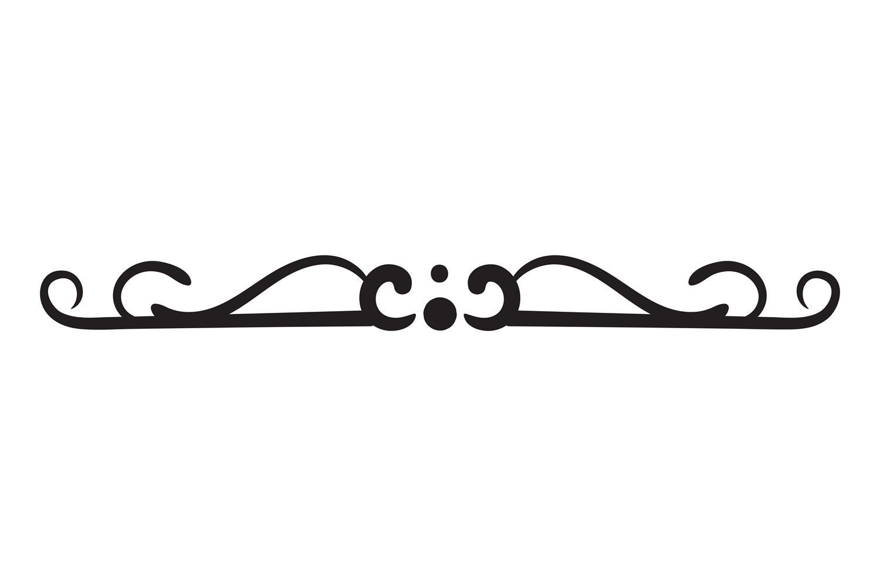
14th May 2025
7.15pm refreshments for a 7.30pm start
Village Hall, Bulkington

- Are you interested in what happens in your village?
- Would you like to get involved in community events?
- Do you have any ideas or suggestions?

We invite any village run clubs to have a table display to advertise what it is you do and hand out flyers. If this is of interest to you, please contact the Parish Clerk on:
clerk@bulkington.org.uk

Please come along for a friendly chat with your Parish Councillors and other village residents about community matters important to you.

